Revision History
Date | Version | Description | Author
06/10/2019 | 1.0 | Organized the Gantt Charts and Risk Planning and Analysis. Adjusted the Document Overview and Configuration Management. Added new workstations. Made changes with the Risk Planning and Risk Analysis section. | Barış Karaer
06/10/2019 | 1.0 | Changed the abbreviations, Software Development Tools. Changed the Gantt Chart. | Alper Sayan
14/10/2019 | 1.0 | Changed the responsibilities section, Changed the name of project,document overview,Software Development Tools and Software Development Rules | Erdem Gönül
14/10/2019 | 1.0 |  | Yağız Naz

TABLE OF CONTENTS

Revision History 1
1 Identification 3
1.1 Document overview 3
1.2 Abbreviations 3
1.2.1 Abbreviations 3
1.3 References 3
1.3.1 Project References 3
2 Software Development Activities 3
2.1 Software development process 3
2.1.1 Overview of process phases 3
2.1.2 Technical documentation 4
2.1.3 Deliverables 4
2.2 Software development tools 4
2.2.1 Workstation 4
2.2.2 Requirements management and documentation 4
2.2.3 Software Design 4
2.2.4 Coding and automated tests 4
2.2.5 Configuration management 5
2.3 Software development rules and standards 5
Responsibilities 5
2.4 Activities and responsibilities 5
3 Risk Assessment 6
3.1 Risk Analysis 6
3.2 Risk Planning 6

Identification

Document overview

This document contains the software development plan of software Hospital Patient Management Application.

This software is a Hospital Patient Management Application that arranges a certain hospitals patients and stores relevant information like patient details, blood type, patients personal details like address and telephone number, treatment plan and a calendar that organizes patients program. Also it has the functions to delete, select certain patients, update them and list them in a certain manner and it includes an interface where patients’ problems and demands are met and answered.

Abbreviations

Abbreviations

HPMS: Hospital Patient Management System
UML: Unified Modeling Language
IDE: Integrated Development Environment
JDK: Java Development Kit
SRS: Software Requirement Specification
STP: Software Test Plan
SDD: Software Design Document
STR: Software Test Report
FTP: File Transfer Protocol

References

Project References

# | Document Identifier | Document Title

Software Development Activities

The section lists and describes the software development activities of Customer Management software development project.

Software development process

This is a course project, which adopts the waterfall model as the software development process.

Overview of process phases

The software development process for the project will be composed of the following phases:
- Planning
- Requirements Analysis
- Design
- Implementation
- Testing and Analysis

These phases will follow each other sequentially, where each phase starts just after the completion of the previous one. The following Gantt chart depicts the planned start date and duration for the phases.

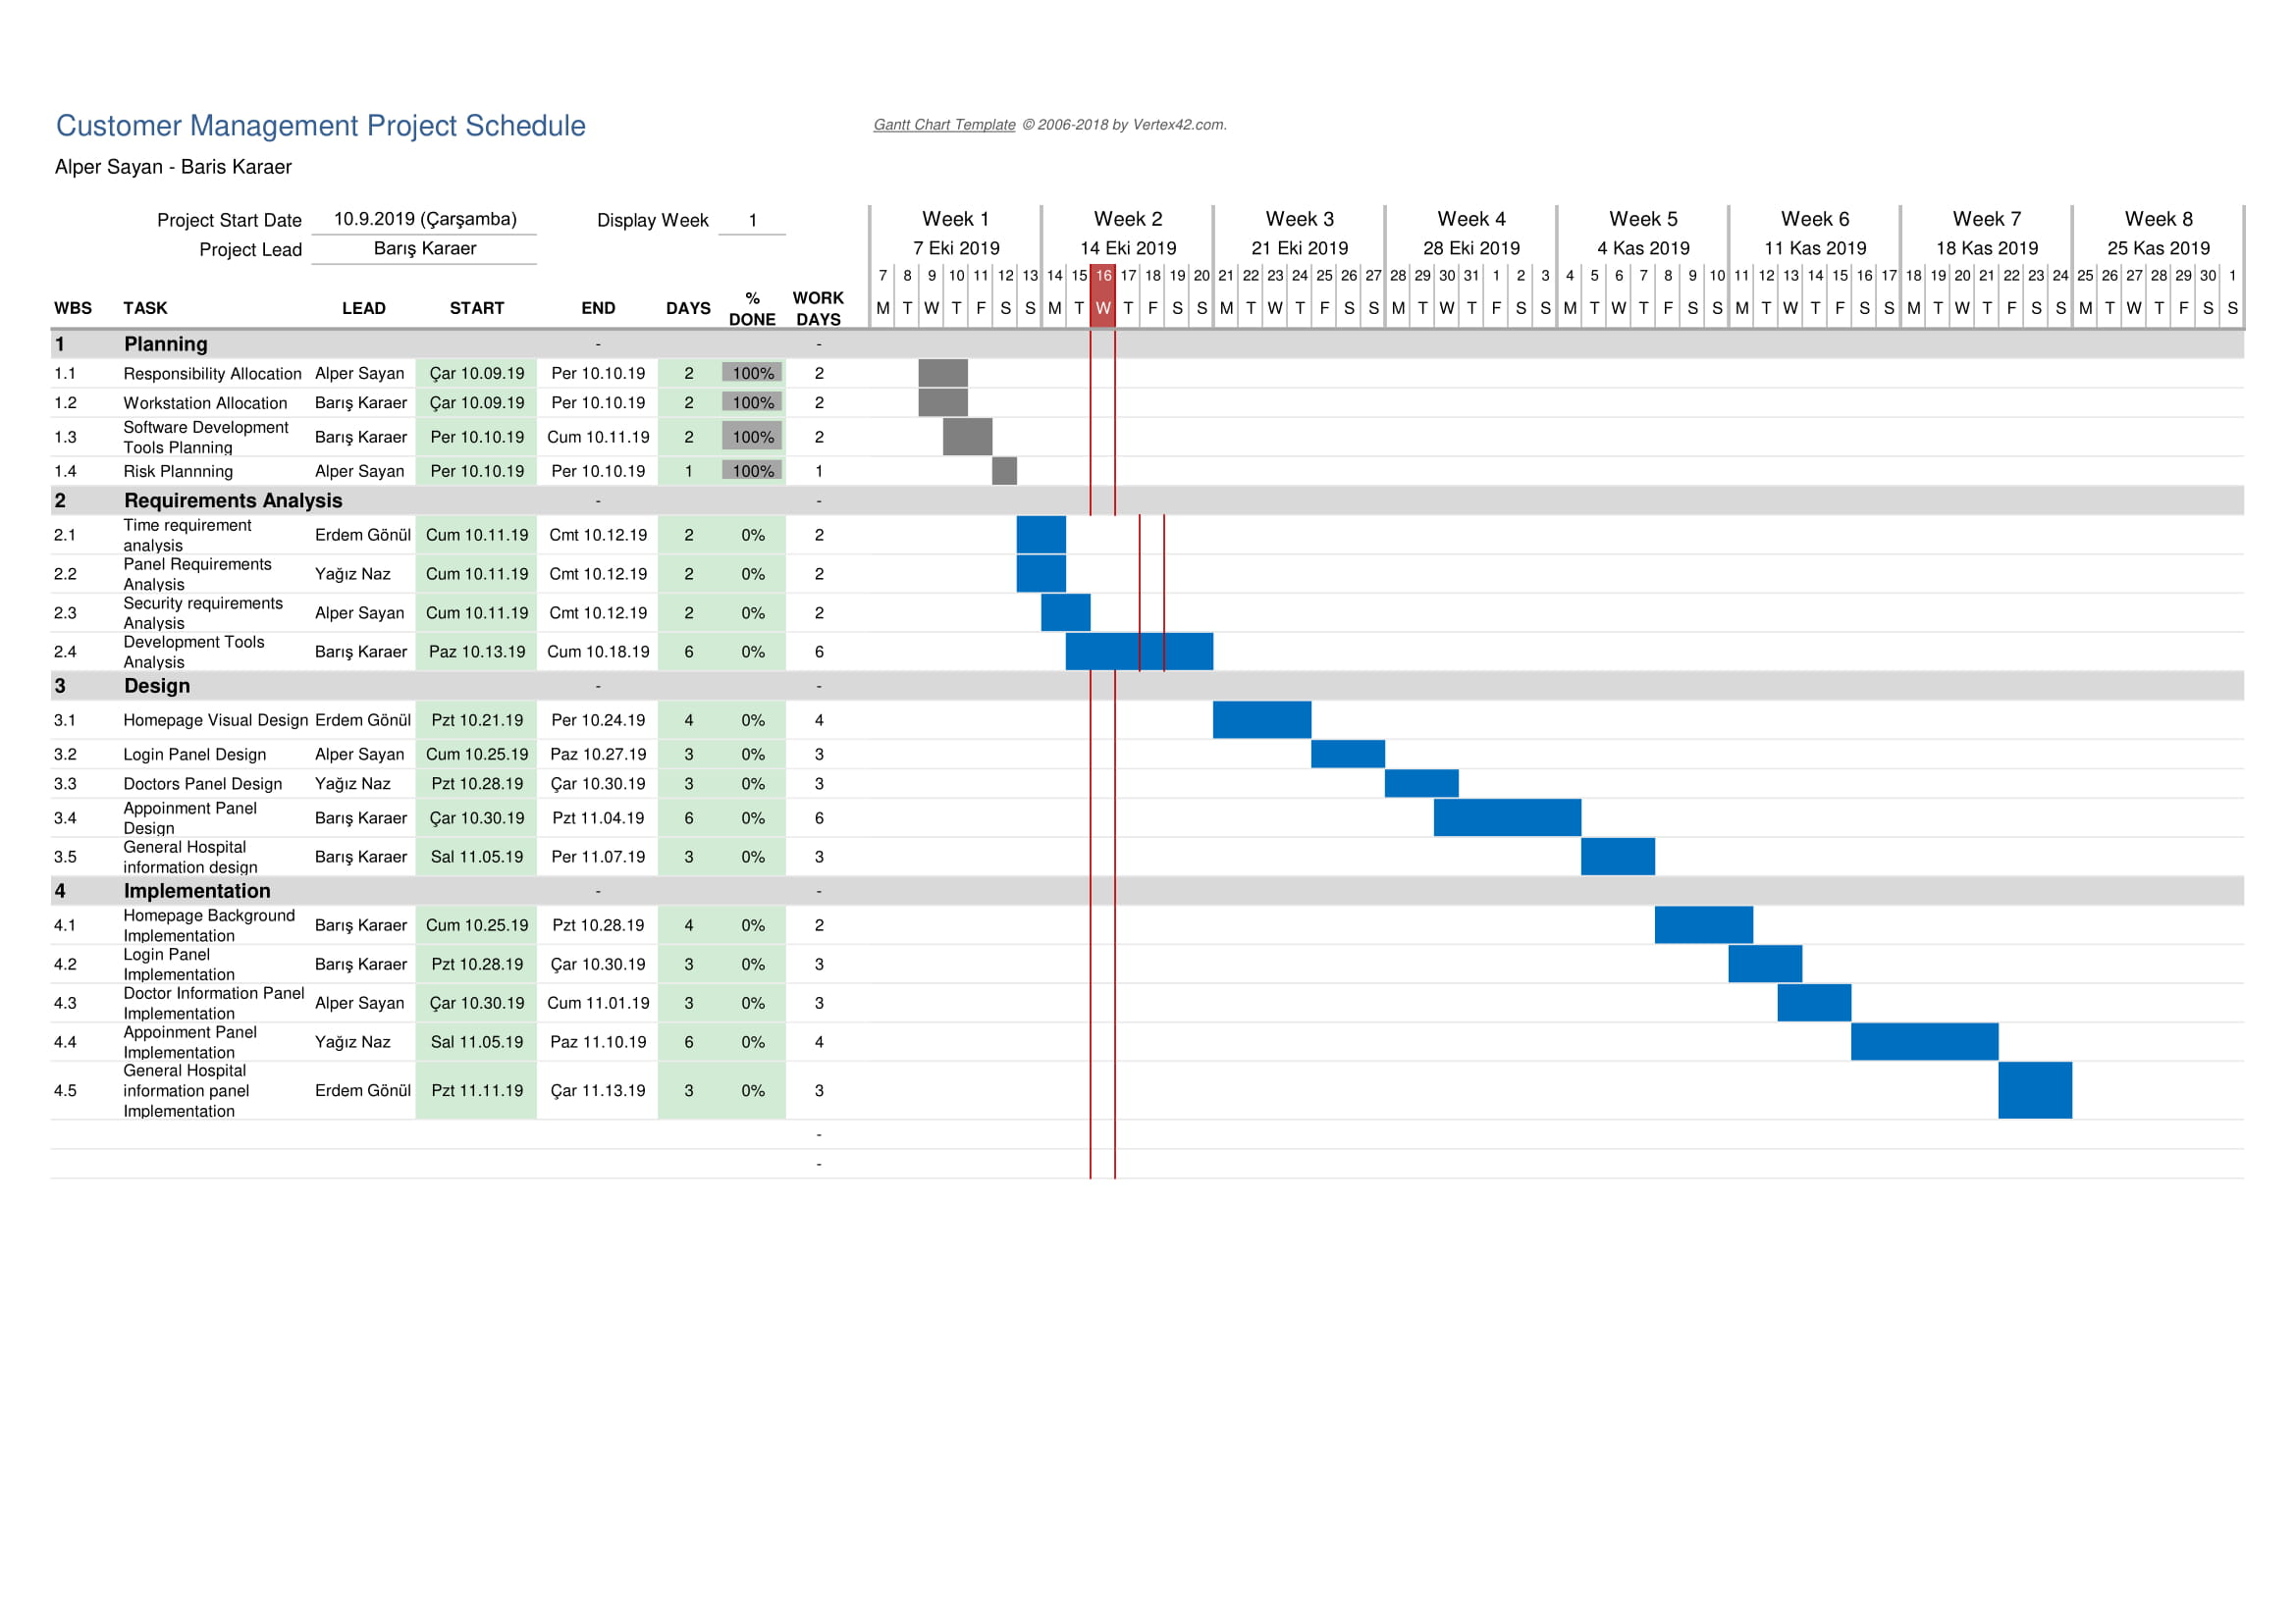
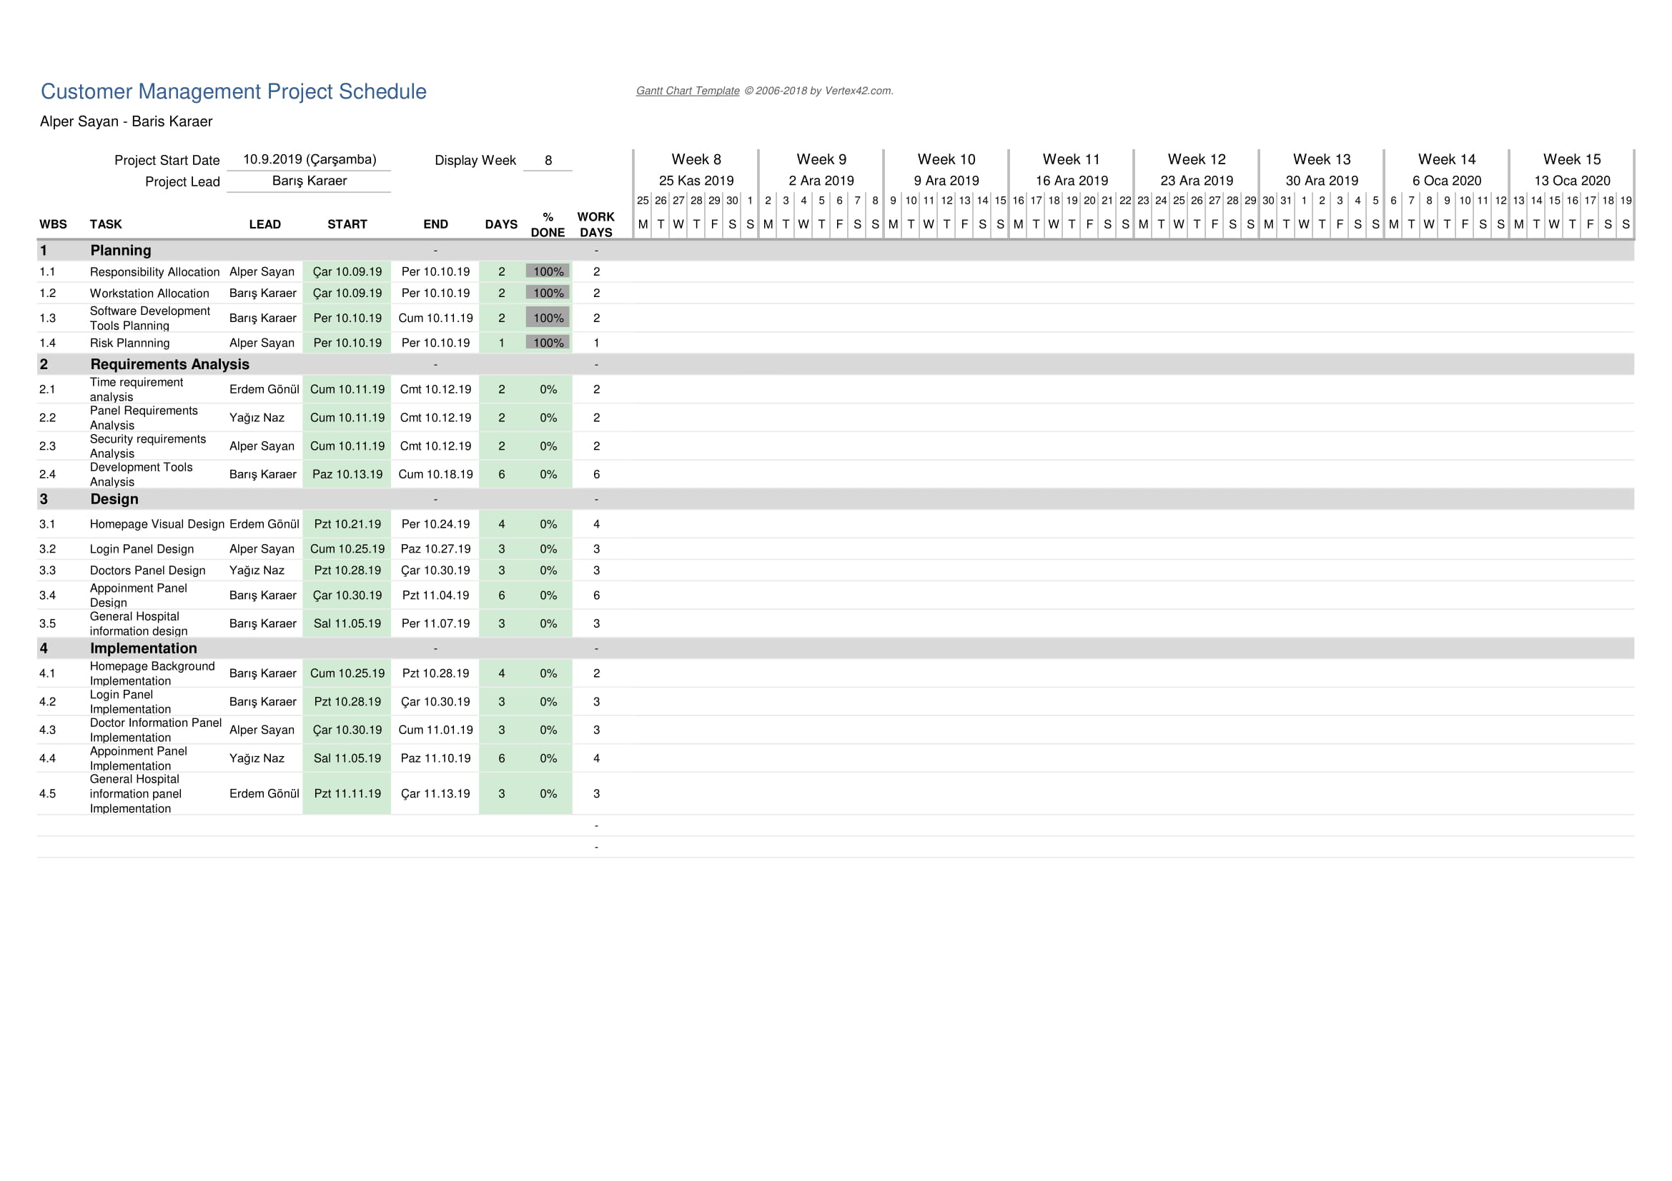

Technical documentation

The following documentation is produced during the software development phases:
- Software specification: SRS, STP
- Software detailed conception: SDD
- Software tests phases : STR
- Software analysis: SAR

Deliverables

The following items will be delivered at the end of the process:
- Technical documentation as outlined in Section 2.1.2
- Software and its configuration files

Software development tools

Workstation

We do not need a strong CPU and RAM in the project because we will run the backend on our Digital Ocean Server. Computers will be only used for coding and testing purposes.

1-Ubuntu Computer (Ahmet Erdem Gönül’s Desktop Computer)
- Intel Core i5 2500K 3.3 GHz
- NVIDIA GeForce GTX 970
- 1 TB HDD
- 16 GB RAM

2-Windows Computer (Barış Karaer’s Laptop Computer)
- Intel Core i7 8750H 2.2 GHz
- NVIDIA GeForce GTX 1060
- 1 TB HDD
- 1 TB SSD
- 16 GB RAM

3-Windows Computer (Alper Sayan’s Laptop Computer)
- Intel Core i7 8750H 2.2 GHz
- NVIDIA GeForce GTX 1060
- 1 TB HDD
- 256 GB SSD
- 16 GB RAM

4-Windows Computer (Yağız Naz’s Laptop Computer)
- Intel Core i7 8750H 2.2 GHz
- NVIDIA GeForce GTX 1050
- 1 TB HDD
- 16 GB RAM

Requirements management and documentation

- Microsoft Word
- Microsoft Excel
- A Web Host
- A Database

Software Design
- StarUML

Coding and automated tests
- dBeaver
- Filezilla FTP Client
- Google Chrome
- Sublime Text
- Atom Editor

Configuration management
GitHub will be used for software configuration management and tracking issues regarding the software development. A public repository will be created for this purpose.

Software development rules and standards

JavaScript ( Official Web Site: https://www.javascript.com/ ), HTML, CSS will be used for Front-End. Vue JS ( https://vuejs.org/ ) will be used as Web Application Framework . Communication with backend will be handled with Axios ( https://github.com/axios/axios ) . Also PHP (https://www.php.net/) programming language will be used to communicate with the database.

UML will be used for software design documentation.

Responsibilities

Activities and responsibilities

Each activity has someone responsible (although multiple project members can be involved in the activity), mandatory.

Activity | Responsibility | Comment
Project management | Barış Karaer | Responsible with the order of the project
Configuration tools management | Alper Sayan, Erdem Gönül, Yağız Naz
Setting up the Development tools | Alper Sayan, Barış Karaer | Making Filezilla FTP Client and dBeaver up and ready in both of our workstation.
Software specifications | Alper Sayan, Erdem Gönül, Barış Karaer | Implementing the Backend and Frontend parts of the project
Database design | Barış Karaer, Yağız Naz | Organizing related datatables and making them executable for the web application

Risk Assessment

Risk Analysis

Risk | Probability | Effects
The time required to develop the software is underestimated. (1) | High | Serious
Software tools cannot be integrated .(2) | Moderate | Tolerable
Required coding is too much for the given time .(3) | Moderate | Serious
Project management and task seperation is too difficult.(4) | High | Tolerable
The size of the software is underestimated .(5) | High | Serious

Risk Planning

For each risk item listed in the previous subsection, provide risk indicators and action(s) to be taken when the risk takes place.

Risk | Strategy
Software Size  Problems | Give each team member a spesific task . Organize each team member to build all of the codes together and test it each step of the way.
Task Seperation Problems | The team manager should organize the GUI and the other codes seperately and give out every team member a task that he/she can handle.
Lack of Time Problem | This problem can be tackled with good task seperation and team work.
Software Tool Problems | Make sure that there are no syntax errors or bugs before making any changes to the PHP files.

http://www.github.com
http://www.uml.org/

